**DAILY ONLINE ACTIVITIES SUMMARY**

|  |  |  |  |  |  |  |  |  |
| --- | --- | --- | --- | --- | --- | --- | --- | --- |
| **Date:** | **23/07/2020** | | | | | **Name:** | **Shailashree** | |
| **Sem & Sec** | **IV sem & B section** | | | | | **USN:** | **4AL18CS077** | |
| **Online Test Summary** | | | | | | | | |
| **Subject** | | **-** | | | | | | |
| **Max. Marks** | | **30** | | **Score** | | | **-** | |
| **Certification Course Summary** | | | | | | | | |
| **Course** | **Predictive modeling and analysis** | | | | | | | |
| **Certificate Provider** | | | **Greatlearning academy** | | **Duration** | | | **2.5hours** |
| **Coding Challenges** | | | | | | | | |
| **Problem Statement1: --------------------------------------------------------------** | | | | | | | | |
| **Status: not Executed** | | | | | | | | |
| **Uploaded the report in Github** | | | | | **YES** | | | |
| **If yes Repository name** | | | | | **Daily Activity Report** | | | |
| **Uploaded the report in slack** | | | | | **YES** | | | |

Online Test Summary: No test is Conducted.

Online Certification Course Summary: Today I Attended the quiz and get the certificate.

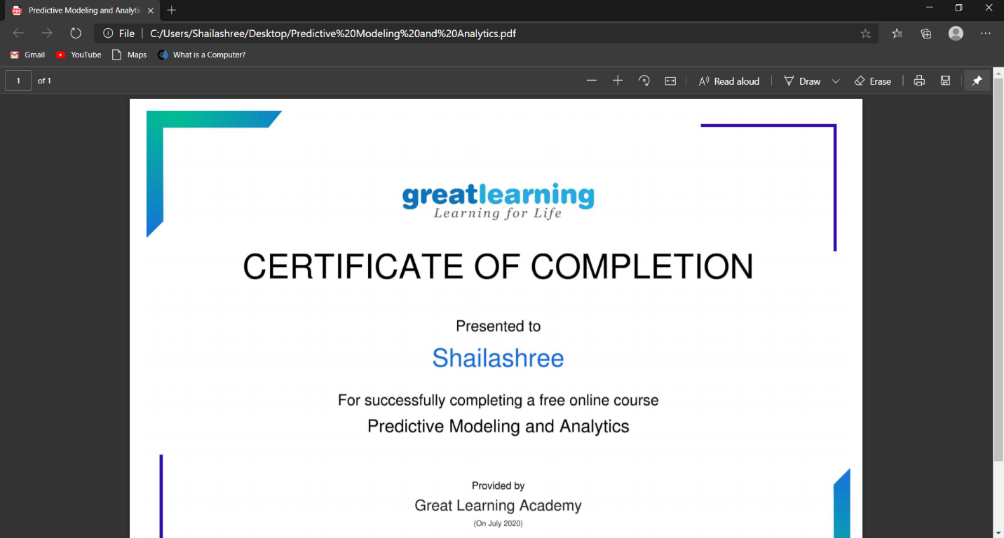

These are the snap shots of today’s sessions.

Online Coding Summary: **No Online coding uploaded.**

Online Training: No training classes are conducted.